Issue: Getting below error when tried to add Witness DB Server to existing DB Mirroring Setup.
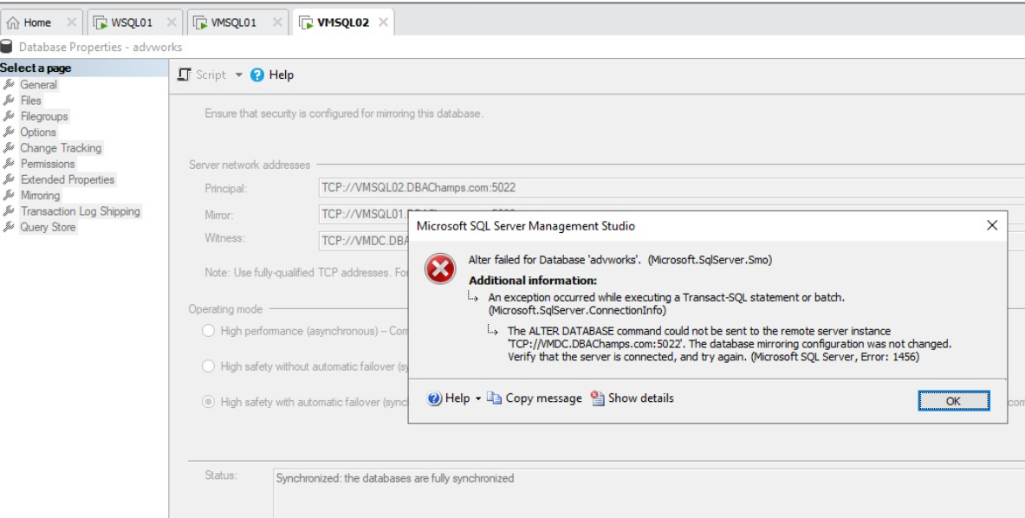

At Principal DB Server (SQL Server 2019 Dev Edition)

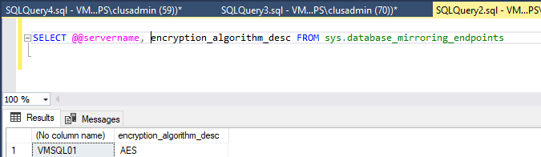

At Mirror DB Server (SQL Server 2019 Dev Edition)

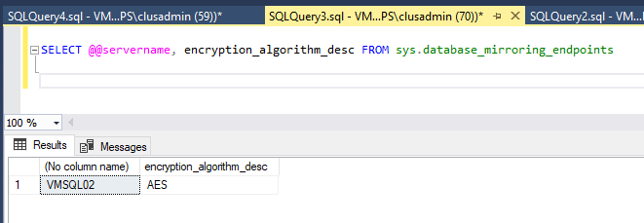
At Witness DB Server (SQL Server 2016 Dev Edition)
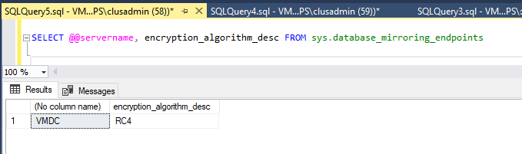
Cause\Analysis:
Primary and Secondary Endpoints were using AES but the Witness was using RC4.

Fix:
On Witness DB Server:
Dropped the Endpoint on and Re-created it with Encryption Algorithm = AES
(similar to Principal and Mirror Endpoints

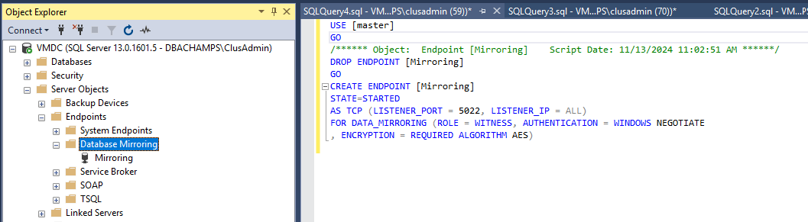

Post above script execution, Witness DB Server was successfully added to existing DB Mirroring.

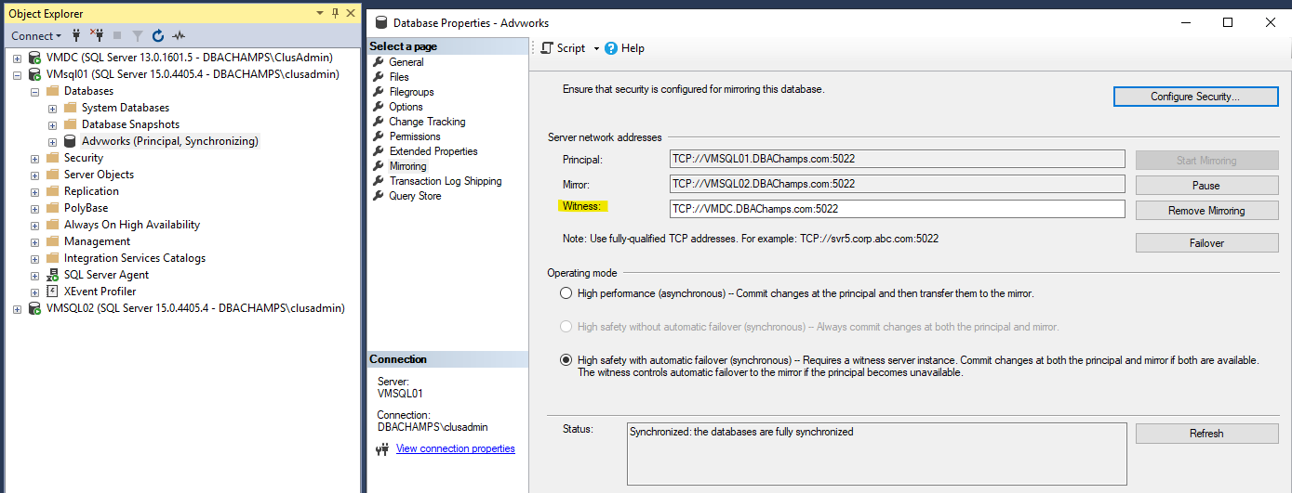
Reference link used to fix the issue:
https://www.reddit.com/r/SQLServer/comments/18mnazq/trouble_adding_a_witness_server_to_a_mirror/?rdt=37536

